**Group Project Deployment Assignment**

**Students:**

Sami Nachwati, Michael Esenwa, Ryan Harris, Maurico Canul Quintal, Mari Shenzhen Uy

**Access Instructions for Ethical Hackers:**

1. **URL:** <https://group8project-c3cedzc9b8hufueg.canadacentral-01.azurewebsites.net/>
2. **Login Instructions:**
   1. Proceed to click the *Login* navigation item in the top right of the screen

* 1. Next, proceed to login with registered account, for instance, using the supervisor email (the.supervisor@mohawkcollege.ca) and password (Password!5)

* 1. Now, logged-in user will be able to see the home page

1. **Build Instructions:**
   1. Visit the GitHub link (<https://github.com/epicwizzle/Group_8_project>)
   2. Next, click the “<> Code” button, then press the “Download ZIP” option

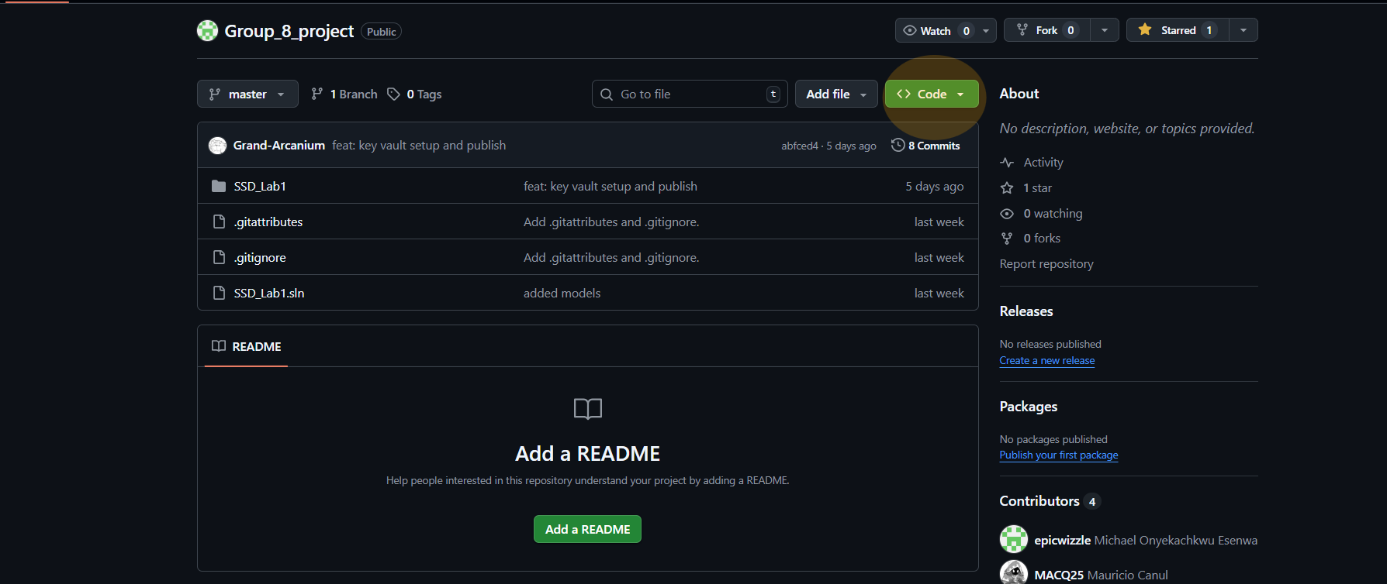

* 1. Extract the contents of the files and then open the folder in Visual Studio
  2. Once that is done, click the *https* start button with its arrow fully green, which would run the project in *Debug Mode*
  3. **DISCLAIMER**: You must have a linked Key Vault to an existing azure account that corresponds to the Key Vault registered. However, because this was locally developed into a personal lab *originally*, this means that a regular user who attempts to clone the repository will not be able to run the application for actual local development/running.

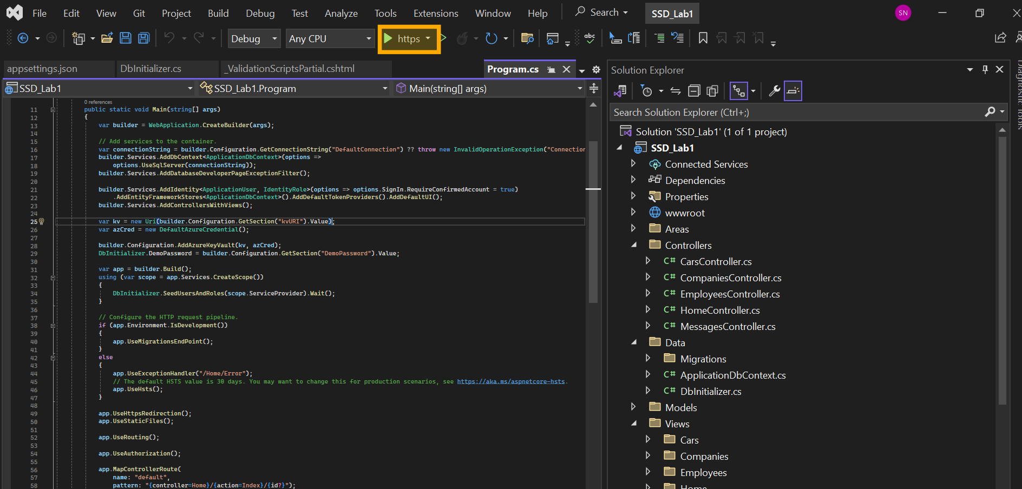

**GitHub Source Code:** <https://github.com/epicwizzle/Group_8_project>

**Deployed Site:** <https://group8project-c3cedzc9b8hufueg.canadacentral-01.azurewebsites.net/>